Planning Document - Gleba Team
Last Revised: MM/DD/YYYY
Team Names: First Last

Goal
What are the general goals of this board
XXX

Requirements
- Power Input/Output
  - XXX V Rail Input @ XXX A
- Major Features
  - Must be able to program using USB-C
  - Must be able to XXX
- Constraints
  - XXX cannot be XXX
- Connectors
  - XXX <-> XXX Power
  - XXX <-> XXX Data1

Components
Parts that contribute significantly to meeting requirements.

MCU: RP2040 2 MB external Flash memory (W25Q16JVUXIQ TR)
- Purchase Link: link
- Datasheet: datasheet
- Design Guide: 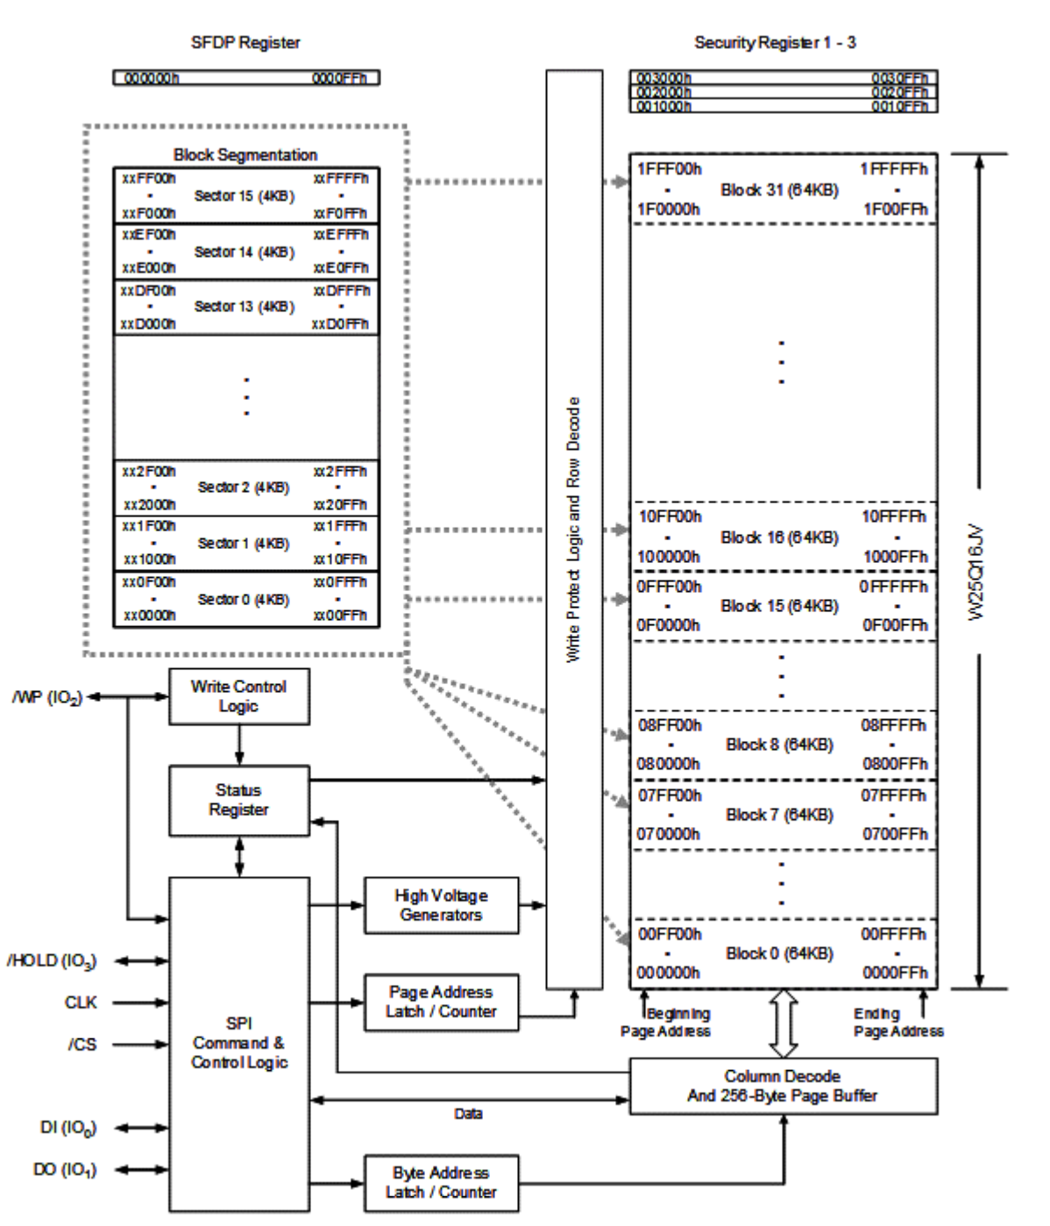
- Pin Configuration: 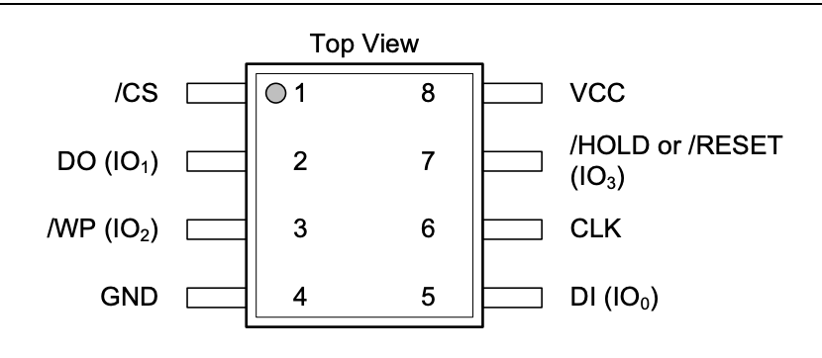
- Design Considerations
  - Power reqs: 2.7-3.6 Voltage range

MCU 12 MHz Crystal (ABM8-272-T3)
- Purchase Link: link
- Datasheet: datasheet
- Design Guide: Doesn’t include a schematic. Has dimension specificities on the data sheet.
- Design Considerations
  - Wide Operating Temperature (-40ºC to +85ºC)

3.3 Voltage Linear Regulator (AP2112K-3.3 )
- Purchase Link: link
- Datasheet: datasheet
- Design Guide: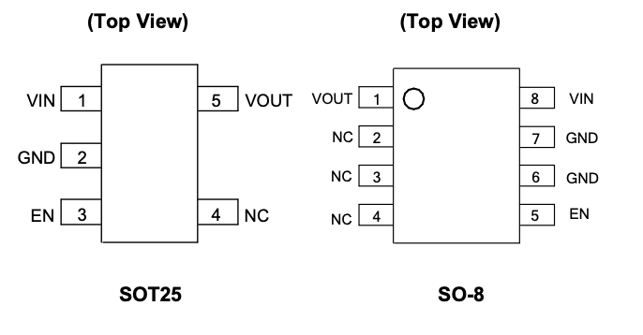
- Typical Application in a Circuit:: 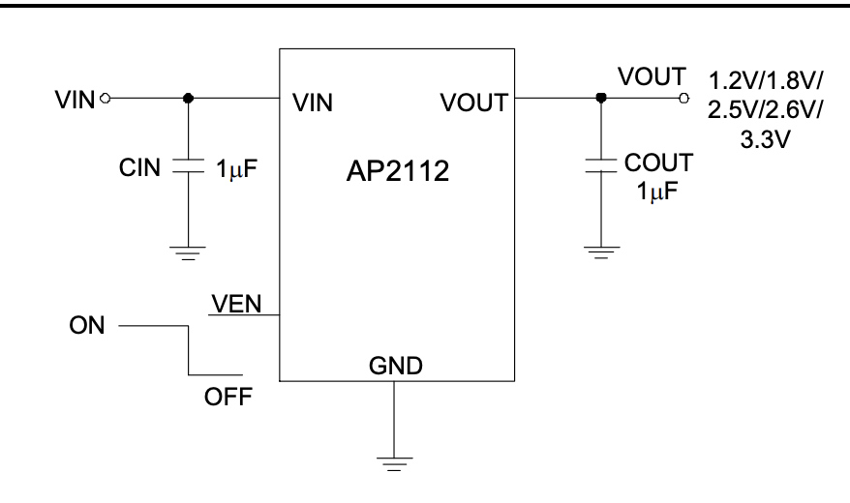
- Design Considerations
  - Power reqs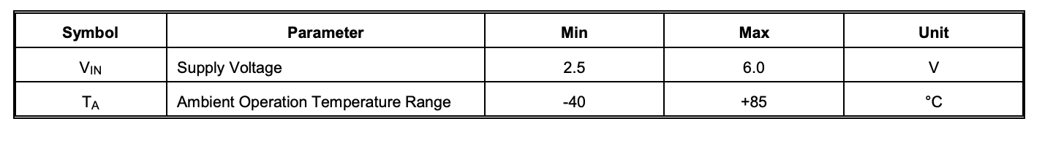

Power MUXing Diodes
- Purchase Link: link
- Datasheet: datasheet
- Design Guide: 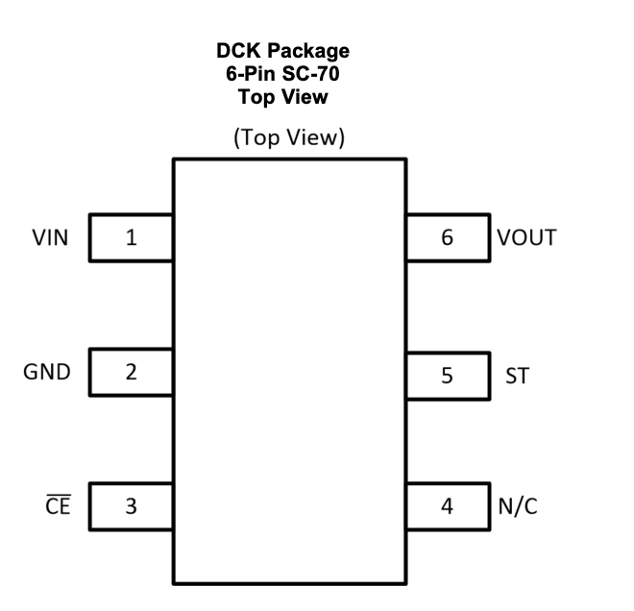
- Design Considerations
  - Power reqs

Button (MCU Reset Buttons) (SKRPABE010)
- Purchase Link: link
- Datasheet: datasheet
- Design Guide: 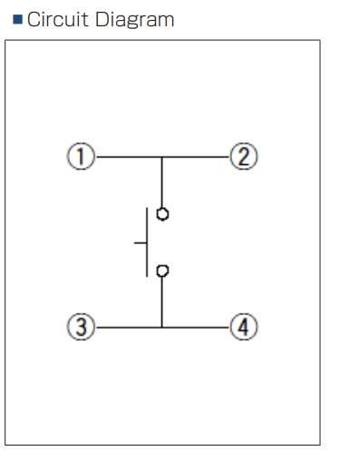
- Design Considerations
  - Absolute Maximum Ratings： 50mA, 16V DC

USB C port (10118194-0001LF)
- Purchase Link: link
- Datasheet: datasheet
- Design Guide: Doesn’t include a schematic.
- Design Considerations
  - Low Level Contact Resistance: Initial 30mΩ max.; after ∆R=±10mΩ (Test condition: EIA-364-23)
  - Insulation Resistance: Initial 1000MΩ min.; after 100MΩ min. (Test condition: EIA-364-21)
  - Dielectric Withstanding Voltage: 100VAC for 1 minute; no breakdown (Test condition: EIA-364-20)
  - Temperature Rise: 30°C max. (Test condition: EIA-364- 70)

IMU (ICM-42605)
- Purchase Link: link
- Datasheet :datasheet
- Design Guide:
- 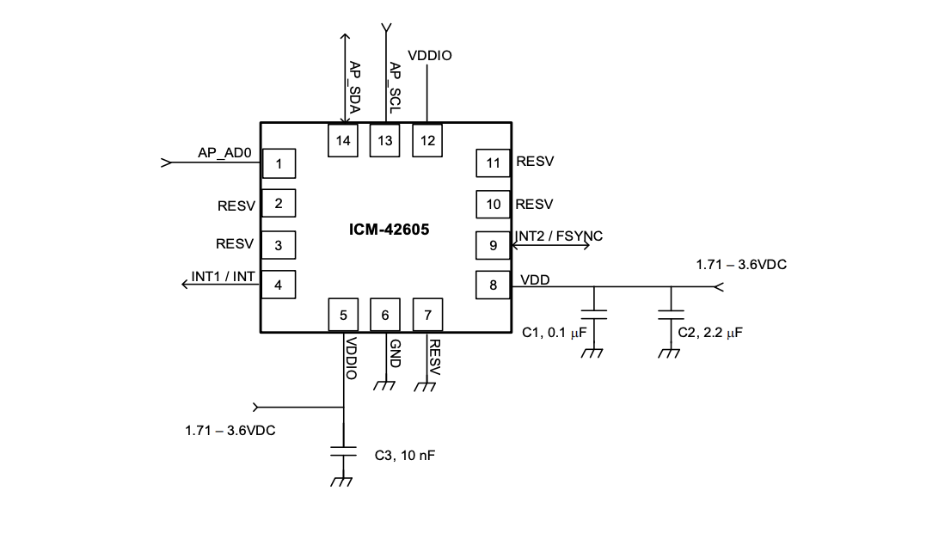
- Design Considerations
  - Power reqs: Typical 1.8 V, maximum: 3.6 V
  - Used for IMU

Color Sensor (VEML3328)
- Purchase Link: link
- Datasheet: datasheet
- Design Guide: 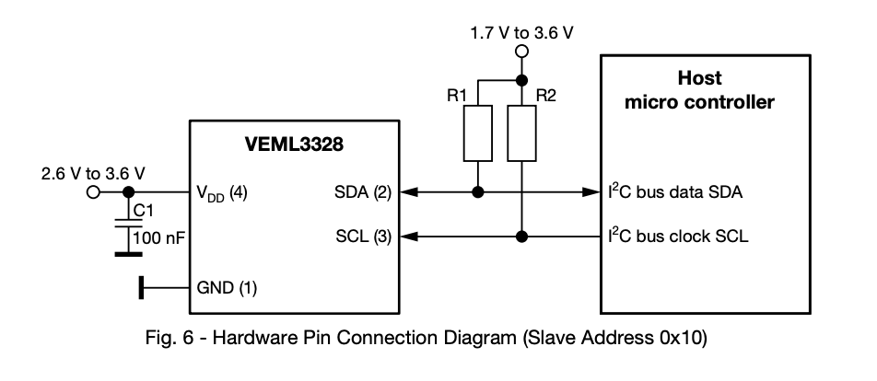
- Design Considerations
  - Power reqs
  - I2C voltage range: 1.7-3.6 V
  - Operating voltage range: 2.6-3.6 V

Hall Effect (TMAG5273C1QDBVR)
- Purchase Link: link
- Datasheet: datasheet
- Design Guide: 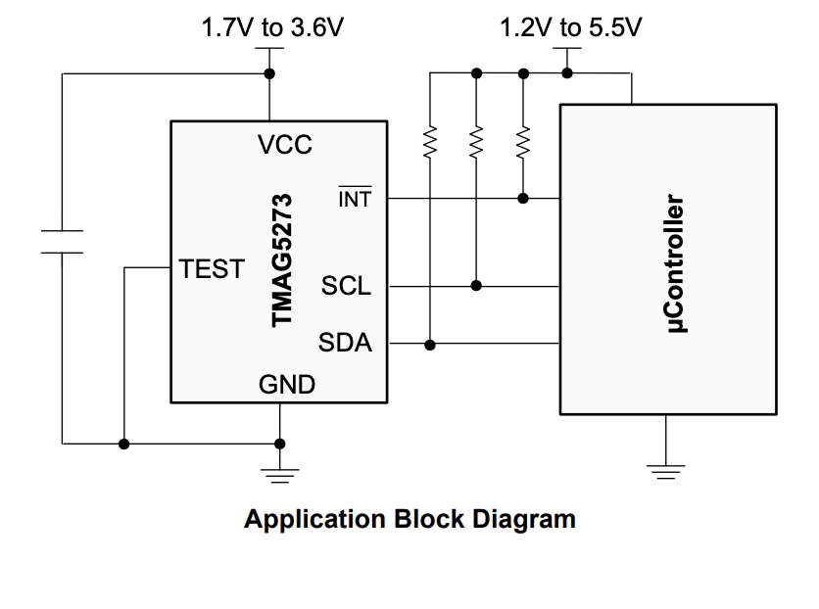
- Design Considerations
  - Power reqs: 1.7-3.6 supply voltage range

Temperature Sensor (LM75ADP)
- Purchase Link: link
- Datasheet: datasheet
- Design Guide: 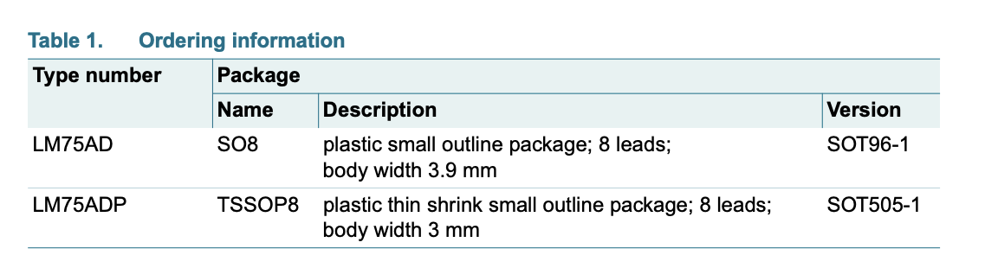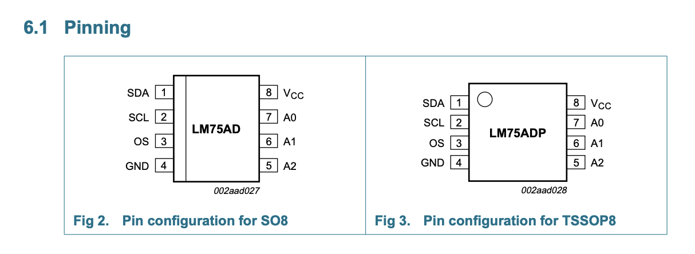
- Design Considerations
  - Power reqs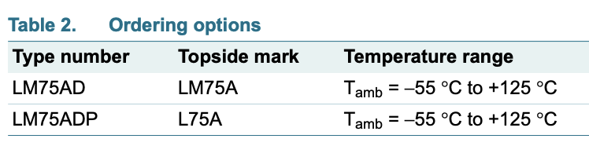

GPIO Expander (TCA9534PWR)
- Purchase Link: link
- Datasheet: datasheet
- Design Guide: 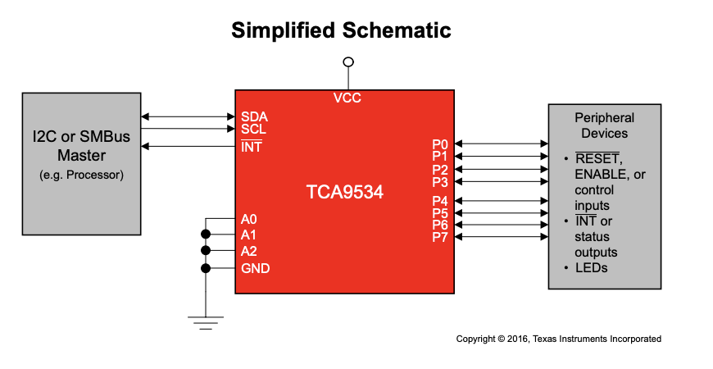
- Design Considerations
  - Power reqs: 1.65 V- 5.5 V

GPIO Expander (dip switch DS01C-254-L-08BE)
- Purchase Link: link
- Datasheet: datasheet
- Design Guide:T
- Design Considerations
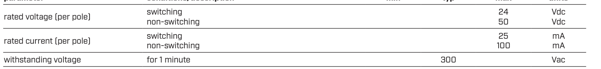
  - Power reqs

GPIO Expander (Resistor Network YC158TJR-0710KL)
- Purchase Link: link
- Datasheet:datasheet
- Design Guide: The code specifies it is YC158 however I have all the variations for your reference. 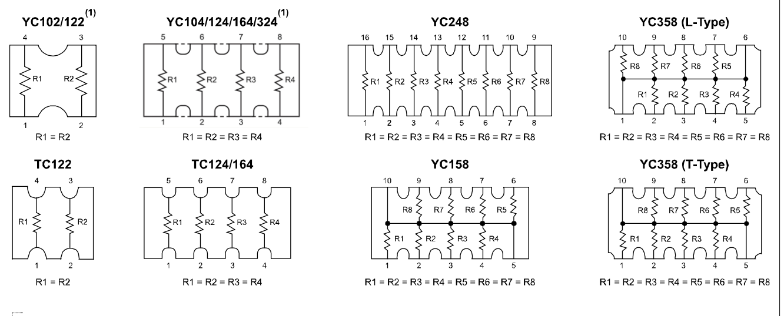
- Design Considerations

LED Controller (IS31FL3254-QFLS4-TR)
- Purchase Link: link
- Datasheet: datasheet
- Typical application in a circuit: 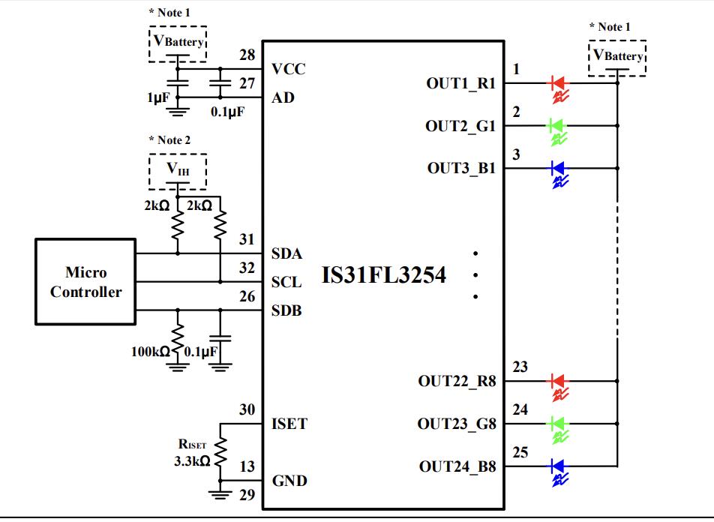
- Pin Configurations: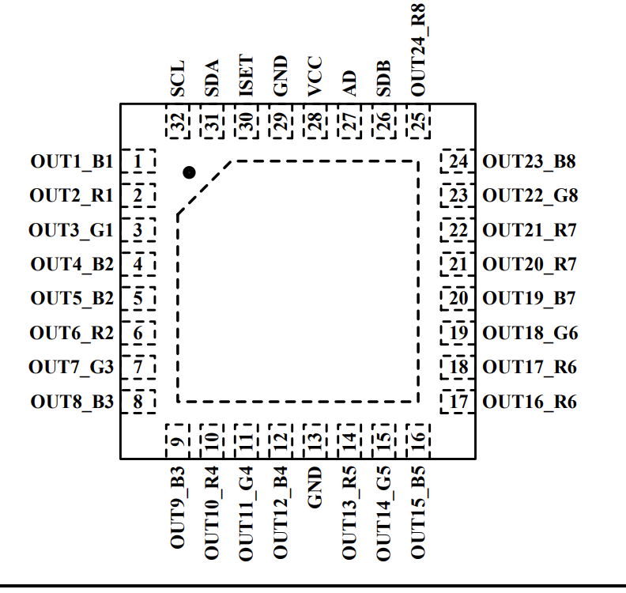
- Design Considerations
  - Power reqs: 2.7-5.5 V supply

LED Controller (RGB LEDs -> CLMVC-FKA-CL1D1L71BB7C3C3)
- Purchase Link: link
- Datasheet: datasheet
- Design Guide: Where 1) Common Anode. 2) Cathode of Blue 3) Cathode of Green. 4) Cathode of Red.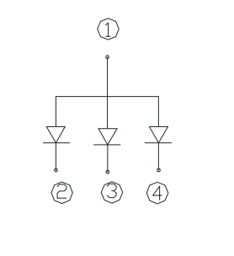
- Design Considerations
  - Power reqs

